PROJECT REPORT
ON

ELECTRONIC RECORDING SYSTEM
SUBMITTED TO THE
UNIVERSITY OF MUMBAI

FOR THE DEGREE OF
BACHELOR OF ENGINEERING
IN

COMPUTER ENGINEERING 2014-2015

Submitted by
Shreerang Paradkar
Kedar Patil
Amit Sawant

UNDER THE GUIDANCE OF
Ms. Sana Shaikh

DEPARTMENT OF COMPUTER ENGINEERING

DON BOSCO INSTITUTE OF TECHNOLOGY
(ENGINEERING COLLEGE)
PREMIER AUTOMOBILES ROAD, KURLA (W) – 400070

ELECTRONIC RECORDING SYSTEM
Submitted in partial fulfilment of the requirement for the Degree of

BACHELOR OF ENGINEERING IN COMPUTER ENGINEERING

by
Shreerang Paradkar Roll no – 42
Kedar Patil Roll no – 44
Amit Sawant Roll no - 57

Under the guidance of:
Ms. Sana Shaikh



DEPARTMENT OF COMPUTER ENGINEERING

DON BOSCO INSTITUTE OF TECHNOLOGY

(ENGINEERING COLLEGE) PREMIER AUTOMOBILES ROAD,

KURLA (W) – 400070

2014-2015

CERTIFICATE

This is to certify that the project report entitled “Electronic Recording System” is a bonafide work of
Shreerang Paradkar Roll no – 42
Kedar Patil Roll no – 44
Amit Sawant Roll no – 57

submitted to the University of Mumbai in partial fulfilment of the requirement for the award of the Degree of Bachelor of Engineering in the Computer Engineering

Ms. Sana Shaikh Dr. Ameya Kumar Tripathy GUIDE

Mr. Imran Mirza Dr. P. Nambiar
H. O. D. (COMPS) PRINCIPAL

Project Report Approval for B.E
This project report entitled Electronic Recording System by Shreerang Paradkar, Kedar Patil, Amit Sawant is approved for the degree of Computer Engineering course of Bachelor of Engineering.

Examiners
1.---------------------------------------------
2.---------------------------------------------

Date:
Place:

DECLARATION
We declare that this written submission represents our ideas in our own words and where others' ideas or words have been included, We have adequately cited and referenced the original sources. We also declare that we have adhered to all principles of academic honesty and integrity and have not misrepresented or fabricated or falsified any idea/data/fact/source in our submission. We understand that any violation of the above will be cause for disciplinary action by the Institute and can also evoke penal action from the sources which have thus not been properly cited or from whom proper permission has not been taken when needed.

-----------------------------------------
(Shreerang Paradkar, Roll No: 42)

----------------------------------------
(Kedar Patil, Roll No: 44)

-----------------------------------------
(Amit Sawant, Roll No: 57)

Date:

ABSTRACT

In medical field there is a growing need for development of software to be used for practical applications rather than only in research field. It is necessary to have a proper health care management system which should be 100% accurate but also should be portable so that every person carries with it as personalized health care system. Doctors need not only to know the main symptoms in a patient but also the other factors in life and surrounding that lead to disease in the patient. For collecting all the necessary information about the patient the doctors needs to spend a lot of time with the patient asking necessary questions to get the important details. The doctor needs to document all the data for further use and needs to remember all the patient details and remedies. The proposed system is intended to develop an Intelligent System using data mining modelling technique, namely, Naive Bayes. It is implemented as Java application in which user answers the predefined questions. It retrieves hidden data from stored database and compares the user values with trained data set. It can answer complex queries for diagnosing heart disease and thus assist healthcare practitioners to make intelligent clinical decisions which traditional decision support systems cannot.

CONTENTS

ABSTRACT vi
CONTENTS vii
LIST OF FIGURES ix
LIST OF TABLES x
ABBREVIATIONS x

- Introduction 11
  - Introduction 11
  - Aim and Objectives 12
1.3 Organization of report 12
- Literature Survey 13
- Problem Statement 14
- System Analysis 15
4.1 Existing System 15
4.2 Proposed System 16
4.3 Analysis 16
4.4 Hardware and Software details 17
4.5 Methodology 17
4.6 Design details 19
- Implementation 23
5.1 Module I 23
5.2 Module II 24
5.3 Module III 26
- Results and Discussion 27
- Project timeline and task distribution 31
- Conclusion 32
- References 33
Appendix 34
Coding conventions
Source Code
IEEE Paper 78
Acknowledgement 79

LIST OF FIGURES
FIGURE NO. | FIGURE CAPTIONS | PAGE NO.
Fig 4.1 | Analysis of algorithm | 16
Fig 4.2 | Architecture of the proposed System | 19
Fig 4.3 | Data Collection | 20
Fig 4.4 | Segregation of symptoms | 21
Fig 4.5 | Probability Generation | 21
Fig 4.6 | Remedy Generation | 22
Fig. 5.1 | Registration Form | 23
Fig. 5.2 | Database Details | 24
Fig. 5.3 | Patients Details | 25
Fig. 5.4 | Symptoms Form | 26
Fig. 6.1 | Registration Form input | 27
Fig. 6.2 | Registration Details | 28
Fig. 6.3 | Patients Details input | 29
Fig. 6.4 | Probability output | 29
Fig. 6.5 | Symptoms form input | 30

LIST OF TABLES
TABLE NO. | TABLE CAPTIONS | PAGE NO.
Table 4.1 | Attributes of Naive Bayes | 18
Table 7.1 | Project Timeline | 31
Table 7.2 | Task Distribution | 31

ABBREVIATION
HDPS | Heart Disease Prediction System
IOS | iPhone Operating System
JDK | Java Development Kit

1. INTRODUCTION
1.1 Introduction
Nowadays to live luxurious life people work like machine in order to earn lot of money hence they forget to take care of their health. Because of this, there is change in the food which they consume, their lifestyle changes. They are more tensed and in very much pressure to earn money so this leads to blood pressure, diabetes and various other diseases at young age. All these reasons lead to negligence of their health which increases the chances of heart disease. Heart is the most essential organ of the human body and if it gets affected then it also affects the other major organs of the body. The aim of proposed system is to design an automated system which would manage complete clinical details, patient’s history and their appointment details in a single database. Doctors will use this system to keep track of the patient consulting to them. The intentions of the proposed system are to reduce over-time pay and increase the number of patients that can be treated accurately.
Many hospital information systems are designed to support patient billing, inventory management and generation of simple statistics. Some hospitals use decision support systems, but are largely limited. They can answer simple queries like “What is the average age of patients who have heart disease? ”, “How many surgeries had resulted in hospital stays longer than 10 days?”, “Identify the female patients who are single, above 30 years old, and who have been treated for cancer.” However they cannot answer complex queries like “Given patient records, predict the probability of patients getting a heart disease.” Clinical decisions are often made based on doctors’ intuition and experience rather than on the knowledge rich data hidden in the database. This practice leads to unwanted biases, errors and excessive medical costs which affects the quality of service provided to patients. The proposed system is that integration of clinical decision support with computer-based patient records could reduce medical errors, enhance patient safety, decrease unwanted practice variation, and improve patient outcome. This suggestion is promising as data modelling and analysis tools, e.g., data mining, have the potential to generate a knowledge rich environment which can help to significantly improve the quality of clinical decisions.
Quality service implies diagnosing patients correctly and administering treatments that are effective. Poor clinical decisions can lead to disastrous consequences which are therefore unacceptable. Hospitals must also minimize the cost of clinical tests. They can achieve these results by employing appropriate computer-based information and/or decision support systems. The healthcare industry collects huge amounts of healthcare data which, unfortunately, are not “mined” to discover hidden information for effective decision making. Discovery of hidden patterns and relationships often goes unexploited. Advanced data mining techniques can help remedy this situation. It is a prototype Heart Disease Prediction System (HDPS) using data mining techniques, namely, Decision Trees, Naïve Bayes. After successfully predicting whether the patient is prone to heart disease or not, the proposed system will provide with the set of questions which the patient will have to answer. Depending upon the answers given by the patient the pattern matching algorithm will generate the corresponding remedy.
1.2 Aim and Objectives
The main objectives of the proposed System are
- The main aim of the proposed System is to reduce the paper work and to avoid missing of data
- To design a Heart Disease Prediction System which will provide automated medical diagnosis of the patient
- Storage of patient’s medical history into Database
- Generating different Diagnosis using Data Mining technique
- To calculate probabilities for a patient about the chances of Heart Disease
- To provide remedies depending upon the symptoms specified by the patient

1.3 Organization of Report
Chapter 1 of the report contains Introduction to this project which explains why this project is undertaken and the concepts associated with it. Chapter 2 of the report consists of Literature survey where key for improvements in existing technologies is determined. Chapter 3 explains problem statement, Chapter 4 deals with designing of the system. Chapter 5 is divided into two phases, Module-I deals job recommendations and module-II deals with skills recommendation for the listed jobs. Chapter 6 discusses results in details. Rest of the report deals with conclusion and future scope

2. LITERATURE SURVEY

According to literature - 3, An Intelligent Heart Disease Prediction System (IHDPS) is developed by using data mining techniques Naive Bayes, Neural Network, and Decision Trees was proposed by Sellappan Palaniappan [3]. Each method has its own strength to get appropriate results. To build this system hidden patterns and relationship between them is used. It is web-based, user friendly & expandable.
According to literature - 1, The System can discover and extract hidden knowledge associated with diseases (heart attack, cancer and diabetes) from a historical heart disease database. It can answer complex queries for diagnosing disease and thus assist healthcare practitioners to make intelligent clinical decisions which traditional decision support systems cannot. By providing effective treatments, it also helps to reduce treatment costs. To enhance visualization and ease of interpretation, it displays the results in tabular and PDF forms [1].
According to literature - 4, This System helps us to understand data extraction using lookup tables by different techniques. Various Notations are used to denote different combinations. Data extraction can be done by performing logical operations on one or more variables in the records, or by comparing variables to values contained in a lookup table[4]. This study focuses on using a lookup table to extract records.

3. PROBLEM STATEMENT

- Development of software to be used for practical applications rather than only in research field.
- Doctors need not only to know the main symptoms in a patient but also the other factors in life and surrounding that lead to disease in the patient.
- The proposed system is intended to develop an Intelligent System using data mining modeling technique, namely, Naive Bayes. It retrieves hidden data from stored database and compares the user values with trained data set.
- It can answer complex queries for diagnosing heart disease and thus assist healthcare practitioners to make intelligent clinical decisions which traditional decision support systems cannot.
- The goal is to develop an automated system, which will facilitate the doctor to have health records of patients and generate e-prescriptions using data mining techniques.
- Once the data is extracted, cleaned and stored in the database, pattern matching is done with the medicine database to analyze the symptoms and provide a list of probable remedies. This will help the doctor to treat the patients.
- The doctor can enter his observations into the database using a desktop application. This will make it easier for him to keep track of all his patients’ recovery processes

4. SYSTEM ANALYSIS
4.1. Existing System
abc Homeopathy (abchomeopathy.com) [5]
abc Homeopathy is a free online homeopathic tool suggests homeopathic remedies based on the symptoms you enter. Homeopathy relies on gathering a detailed picture of your complaint before Homeopathic Remedies can be correctly prescribed. Therefore, for this homeopathic remedy finder software to work properly, you should enter all your symptoms, using the search or the tick categories, or both. You can add symptoms at any stage; you do not have to add them all at the beginning. [5]
Working of abc Homeopathy:
Enter your symptoms
The home page of the homeopathic remedy finder offers you a choice of Searching or Browsing to find your symptoms. If you choose to search, bear in mind that you are searching for symptoms, not a condition. (Search for headache, sore throat, exhaustion, sneezing, coughing and running nose rather than flu). It also allows users to group a symptom set by the name of a condition, but be aware that these conditions will not be exhaustive lists of possible symptoms. Although these are quicker and more convenient to use, you should supplement them with other symptoms specific to your case. The more symptoms you include, the more accurate the final result will be
Refine your symptoms
In most cases, the results of searching or ticking boxes produce more options such as exactly where, when and how symptoms occur. Depending on the precision of your search, you may also be presented with more options after that, as sub options from what you have already ticked. Homeopathy requires exact definitions of your symptoms to be useful. Therefore, there will be a maximum of 5 screens of tick-boxes to refine your symptoms. You can choose to ignore them, and just press next at any time to see the best remedy matches up to that point; you can of course then use the back button on your browser to resume ticking. If none apply, just press next.
Select a remedy
The aim is to find the one remedy which best matches all your symptoms. When there are no more questions to be asked, you will be presented with a screen showing details of the best remedy for your complaint. Usually the remedy will not be appropriate for all the symptoms you enter, and often there are other equally likely remedies. To differentiate between the most likely remedies, you can also see the remedy grid, with the symptoms down the left and the remedies across the top, by pressing the next button again. They are arranged with the best match on the left, and then less likely remedies to the right. A maximum of 12 remedies are shown at any time. With the remedy grid, you can easily compare remedies, and even rearrange the grid, prioritizing any symptom and discarding others.
4.2 Proposed System
The Proposed system consists of the following modules:
Module – I :- Registration and Data collection
- The patient needs to have his/her account. For that the patient needs to enter his personal details and create an account.
- The patient will have to fill the forms containing questionnaires. After the completion of forms, the proposed system database will be updated with the patient records.
Module – 2 :- Finding the Probability
- After the collection of the data entered by the patient, the proposed system will generate the probability whether the patient is in risk of a heart disease or not.
Module – 3 :- Generating the Remedy
- Depending upon the probability of the heart disease of the patient, the further questions will appear.
- The symptoms will be entered by the patients and depending upon the probability and the symptoms, the remedy will be generated and will be displayed.

4.3 Analysis
Analysis on classification algorithms
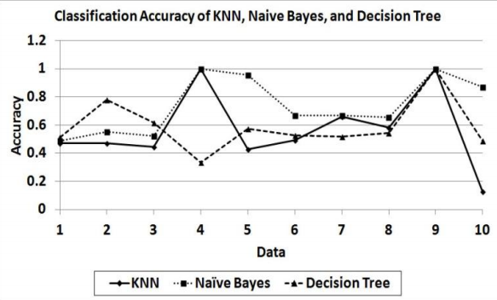
Fig 4.1 Classification of different algorithm
Although it is a simple method, Naïve Bayes can outperform more sophisticated classification methods. In this experiment, Naïve Bayes outperforms Decision Tree and k-Nearest Neighbour. The reason for Naïve Bayes good performance is not because there are no attribute dependences in the data. In fact its good performance is caused by the zero-one loss function used in the classification.

4.4. Hardware and software details
4.4.1 Software Required
- XAMPP
- Eclipse
- JDK
- NetBeans
- MySQL
4.4.2 Hardware Required
- Server to connect to the database
- 2 GB Ram
- Pentium processor

4.5 Methodology
The Heart Disease Prediction System (HDPS) is done using Naïve Bayes Data mining technique [1].
Record set with medical attributes was obtained from the Cleveland Heart Disease database. With the help of the dataset, the patterns significant to the heart attack prediction are extracted.
Questionnaires are also sharply limited by the fact that respondents must be able to read the questions and respond to them.
The records are split equally into two datasets:
- Training dataset.
- Testing dataset.
The attribute “Diagnosis” is identified as the predictable attribute with value “1” for patients with heart disease and value “0” for patients with no heart disease. “PatientId” is used as the key; the rest are input attributes. It is assumed that problems such as missing data, inconsistent data, and duplicate data have all been resolved.
Table 4.1 Attributes of Naive Bayes
Serial No. | Attribute | Description
1 | Sex | value 1: Male  value 0: Female
2 | Chest Pain Type | value 1: typical type 1 angina  value 2: typical type angina  value 3: non angina pain  value 4: asymptomatic
3 | Fasting Blood Sugar | value 1: > 120 mg/dl  value 0:< 120 mg/dl
4 | RestECG | resting electrographic results  value 0 : normal  value 1 : 1 having ST-T wave abnormality  value 2 : showing probable/definite left ventricular hypertrophy
5 | Exang | exercise induced angina  value 1 : yes  value 0 : no
6 | Slope | the slope of the peak exercise ST segment  value 1: unsloping  value 2: flat  value 3: downsloping
7 | CA | number of major vessels colored by floursopy (value 0 – 3)
8 | Thal | value 3: normal  value 6: fixed defect  value 7: reversible defect
9 | Trest Blood Pressure | (mm Hg on admission to the hospital)
10 | Serum Cholesterol | (mg/dl)
11 | Thalach | maximum heart rate achieved
12 | Oldpeak | ST depression induced by exercise
13 | Age | In year
14 | Height | In cms
15 | Weight | In kgs
Table 4.5 Attributes of Naive Bayes

4.5.1 Bayes Rule
A conditional probability is the likelihood of some conclusion, C, given some evidence/observation, E, where a dependence relationship exists between C and E.
This probability is denoted as P(C |E) where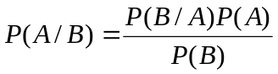......... (I)
For proposition A and evidence B
- P(A), the prior, is the initial degree of belief in A.
- P(A | B), the posterior, is the degree of belief having accounted for B.
- P(B | A) / P(B) represents the support B provides for A [1].

4.6. Design details
4.6.1 Architecture of the proposed System
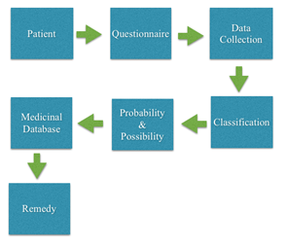
Figure 4.2 Architecture of the proposed System

The proposed system is done as Java Application. The patients need to answer various questions and the data is collected and then stored in the database. The data is classified (Figure - 4.2) based on the different possibilities. The patient can check whether he is prone to heart attack or not. The data entered by the patient is considered and the probability is generated whether the patient is in risk of getting the heart attack or not. Further questions are asked to the patient and depending upon the answers, remedy is generated. The medicine corresponding to a particular symptom is displayed. The doctors can view the patient details as well as the medicine database.

The proposed system is divided into two parts
- Data collection
- Probability generation
- Generation of remedies

4.6.2 Data Collection
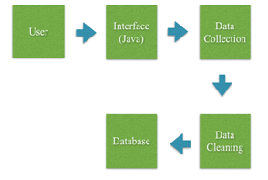
Figure 4.3 Data Collection

Data collection (Figure – 4.3) is meant to be used by the patients and the probability generation to be used by doctors or patients. In Data collection the main functionality of the system is carried out. The system would direct the patients to answer a few questions in order to get necessary diagnosis. The information collected from the patient includes personal details, associated complaints and reactions experienced. The symptom file is generated from the medicine database. The symptoms from the segregated sections are pattern matched with symptoms present in the symptom file. The matched symptoms are then used to generate remedies from the medicine database and the probability of the remedies. The symptoms are segregated depending upon the attributes (Figure – 4.4).

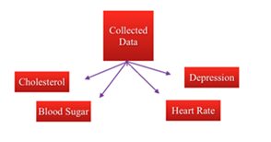
Figure 4.4 Segregation the symptoms

4.6.3 Probability Generation
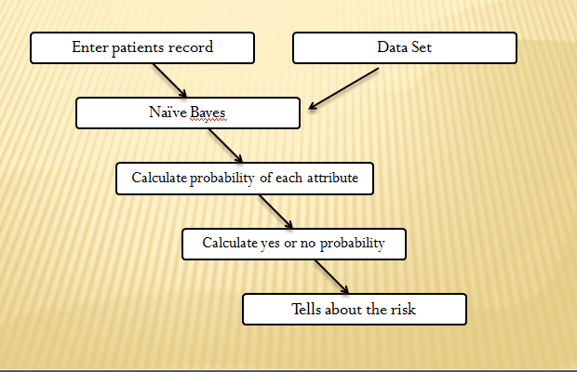
Fig 4.5 Probability Generation
In the above Fig 4.5, the patient will enter his records and the algorithm will generate the probability depending upon the following steps
- The values in data set will be filtered in order to get discrete values.
- Then probability of each attribute will be calculated and then the combined probability will be shown.

4.6.4 Remedy generation of proposed system
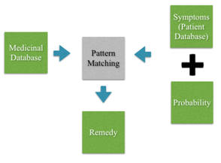
Figure 4.6 - Remedy generation

The symptoms are taken from the patient database and segregated into categories. These symptoms categories are matched with the symptom file created from the medicine database. After pattern matching the necessary remedies with their probability is displayed (Figure – 4.6).

5. IMPLEMENTATION

5.1 Module-I Data Collection and Registration
The first module i.e Data Collection and Registration consists of registration page where the patient’s data is collected and stored in the database.

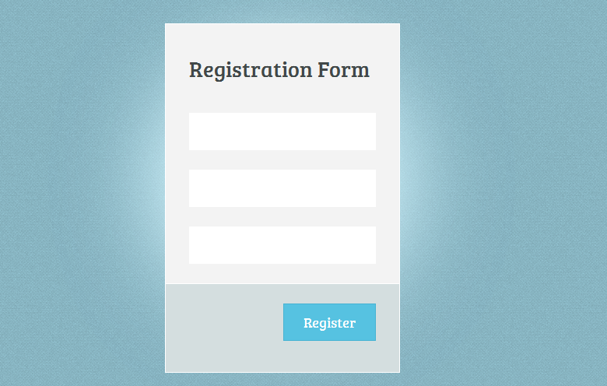
Fig. 5.1 Registration Form

In the above figure 5.1, there are 3 fields which consists of username, password and confirm password. The patient while creating a new account has to enter the desired username which the patient wants, enter the password, and then again he will have to enter the password to confirm whether the password enter previously matches with the password entered now.
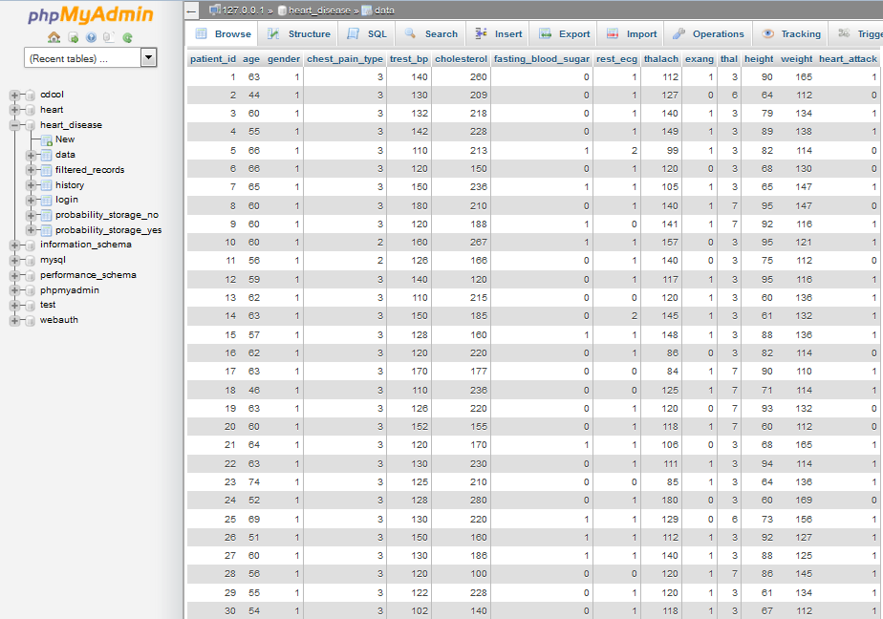
Fig 5.2 Database Details

In the above figure 5.2, the database details have been specified. Different attributes, their corresponding values etc have been specified.

5.2 Module-II Probability Finder
In the second module, i.e the probability finder, the patient will have to enter the values of the attributes which are specified in the form (Fig 5.3). The algorithm will accept the data from the patient; it will check in the database and then show the result.
The steps are as follows
- Once the data has been entered, depending upon the different conditions, the data will be filter.
- After the data is filtered, it will be classified into 2 different things i.e probabilities with yes as result and no as the result.
- The probability of each attribute will be calculated
- In the end, the net probability will be calculated depending upon the individual probability
- In this way the probability whether he is suffering from heart disease or not will be shown.
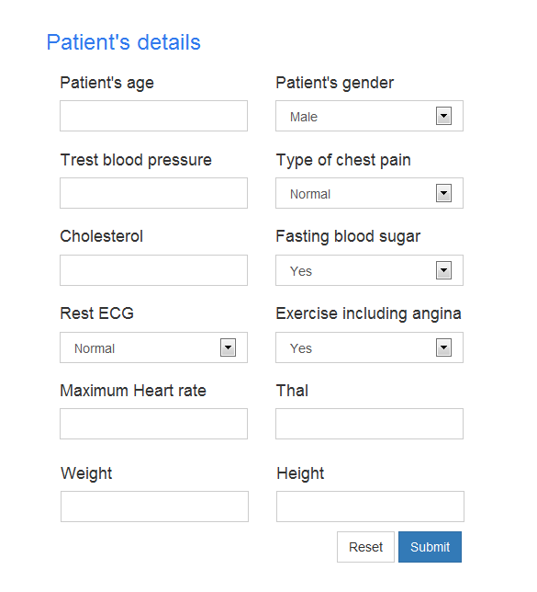
Fig 5.3 Probability Finder form

5.3 Module-III Remedy Generation
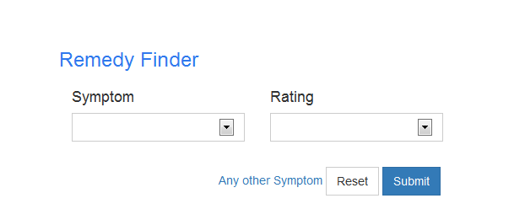
Fig 5.4 Remedy Generation Form

In the third module, i.e the remedy generation module, the patient will have to enter the symptoms which he/she is facing. Also the patient will have to enter the rating i.e the scale of the symptom (from 0-9). Depending on it the patient will be shown with the proper remedy.

6. RESULTS

6.1 Data Collection and Registration
A new patient is registered successfully. The data is collected and stored in the database which is used for further classification and filtering of records to make the output more efficient and proper.

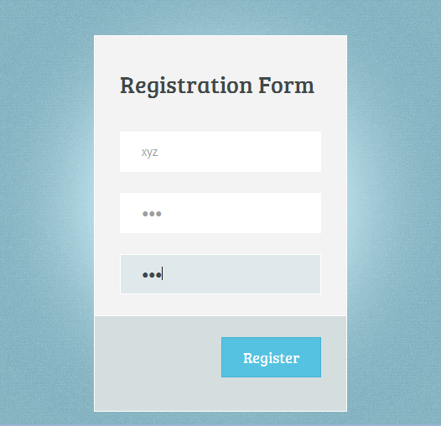
Fig 6.1 Registration Form
In the above figure 6.1, there are 3 fields which consists of username, password and confirm password. The patient while creating a new account has to enter the desired username which the patient wants, enter the password, and then again he will have to enter the password to confirm whether the password enter previously matches with the password entered now.

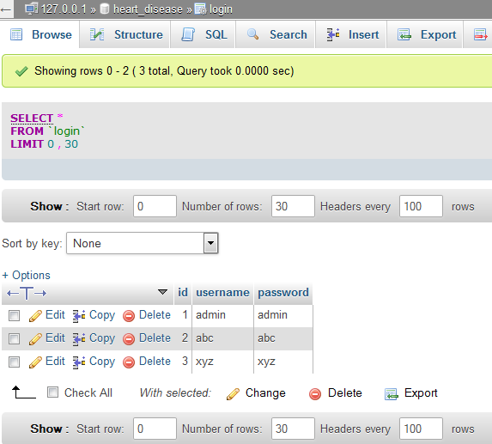
Fig 6.2 Registration Result
In the above Fig 6.2, the patient who entered the value for registering his account has successfully registered and the data is stored in the database.

6.2 Probability Finder
The form consists of various attributes which are supposed to be filled by the patient in order to check for the probability whether he is suffering from heart disease or not. Once he has entered the data, the dataset present in the database is filtered and then the probability is calculated of each attribute and then combined probability is generated.

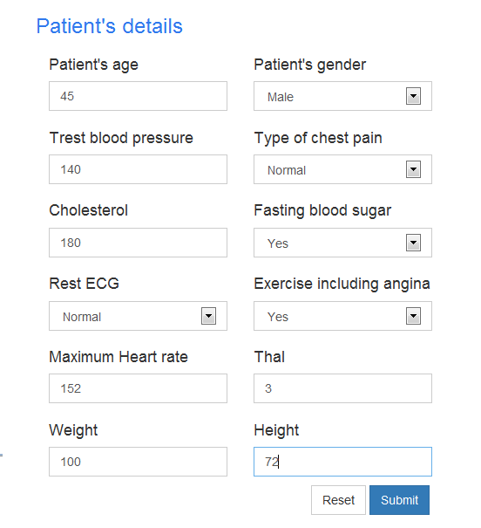
Fig 6.3 Details Form

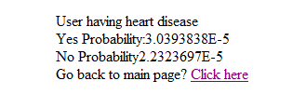
Fig 6.4 Heart Disease Result

In the above Fig 6.3, the patient answers to the various answers which are asked for checking whether he is suffering from heart disease or not. In the Fig 6.4, the patient is shown the probability of his disease in terms of yes or no.

6.3 Remedy Generation
The form consists of 2 attributes which are supposed to be filled. The 2 attributes are Symptom and Ratings. The patient will have to enter the symptom which he/she is facing and also the rating of it. The symptom will be searched in the database and remedy will be provided.
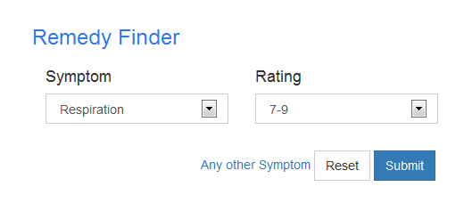
Fig 6.5 Remedy Finder Form

The above Fig 6.5 shows the remedy finder form where the patient needs to enter the symptom and scale the level of symptom from 0-9.

7. PROJECT TIMELINE AND TASK DISTRIBUTION

Table 1: Project Timeline

Table 7.1 Project Timeline
Month | Work to be done
June-July | Study and understand the working of different attributes which are directly or indirectly involved in Heart Disease
August-September | Research on methods to be applied
October | Data collection, identification of open source
January-February | Coding, Implementation and final testing.
March-April | Delivery/Deployment of project with documentation

Table 2: Task Distribution

Table 7.2 Task Distribution
Name | Data Collection | Probability Finder | Remedy Generation | Black Book | Weekly Report | IEEE Paper
Shreerang Paradkar | No | Yes | Yes | Yes | Yes | Yes
Kedar Patil | Yes | No | Yes | Yes | Yes | Yes
Amit Sawant | Yes | Yes | No | Yes | Yes | Yes

8. CONCLUSION

Decision Support in Heart Disease Prediction System is a Java Application which is intended to be done using Data mining technique “Naive Bayesian Classification technique”. The system extracts hidden knowledge from the database. HDPS can be further enhanced and expanded. It can also incorporate other data mining techniques. Another area is to use Text Mining to mine the vast amount of unstructured data available in healthcare databases.

FUTURE WORK

- Mobile Application
- We can develop mobile application on Android and IOS platforms for making the system easily available.
- We can provide a SMS facility that will send a message to the patient regarding his heart condition and how to take effective measures to reduce the danger.

- Pacemaker
- We can integrate the system with pacemaker. A pacemaker is a small device that's placed in the chest or abdomen to help control abnormal heart rhythms.
- This device uses electrical pulses to prompt the heart to beat at a normal rate.

9. REFERENCES

- “Prediction System for Heart using Naive Bayes”, Shadab Adam Pattekari and Asma Parveen, International Journal of Advanced Computer and Mathematical Sciences ISSN 2230-9624. Vol 3, Issue 3, 2012, pp 290-294.
- ‘http://www-igm.univ-mlv.fr/~lecroq/string/node14.html’, Boyer Moore, accessed on 25th April,2014.
- SellappanPalaniappan, RafiahAwang, "Intelligent Heart Disease Prediction System Using Data Mining Techniques", IJCSNS International Journal of Computer Science and Network Security, Vol.8 No.8, August 2008.
- Anthony M. Dymond, “Data Extraction Methods in Medium and Large Databases”, Dymond and Associates, LLC, Concord, CA.
- “abchomeopathy.com”

APPENDIX
Coding Conventions
Source code

- Authenticate User
package test;
import java.io.IOException;
import java.io.PrintWriter;
import javax.servlet.ServletException;
import javax.servlet.annotation.WebServlet;
import javax.servlet.http.HttpServlet;
import javax.servlet.http.HttpServletRequest;
import javax.servlet.http.HttpServletResponse;
import javax.servlet.http.HttpSession;
import java.sql.*;
/**
* Servlet implementation class AuthenticateUser
*/
@WebServlet("/AuthenticateUser")
public class AuthenticateUser extends HttpServlet {
private static final long serialVersionUID = 1L;
public AuthenticateUser() {
super();
// TODO Auto-generated constructor stub
}
* @see HttpServlet#doPost(HttpServletRequest request, HttpServletResponse response)
*/
protected void doPost(HttpServletRequest request, HttpServletResponse response) throws ServletException, IOException {
// TODO Auto-generated method stub
String username = request.getParameter("username");
String password = request.getParameter("password");
try
{
Class.forName("com.mysql.jdbc.Driver");
Connection con =DriverManager.getConnection ("jdbc:mysql://localhost:3306/heart_disease","root","");
Statement st = con.createStatement();
String query = "select * from login where username='"+username+"' and password='"+password+"'";
ResultSet rs = st.executeQuery(query);
if(rs.next())
response.sendRedirect("decide.jsp");
else
{
try
{
PrintWriter out = response.getWriter();
response.setContentType("text/html");
out.write("<script type=\"text/javascript\">");
out.write("alert('Username or password is incorrect')");
out.write("</script>");
}
catch(IOException e)
{
e.printStackTrace();
}
response.sendRedirect("index.jsp");
}
}
catch(SQLException e)
{
e.printStackTrace();
}
catch(ClassNotFoundException e)
{
e.printStackTrace();
}
}
}

- Calculate Probability
package test;
import java.sql.*;
import java.util.ArrayList;
import java.util.List;
public class CalculateProbability {
float HA_YES, HA_NO; // important factors
public static float EXTERNAL_HA_YES,EXTERNAL_HA_NO;
Connection con = null;
public static boolean calculatingTrue = true;
public void calculateProbability() {
con = Database.getConnection();
try {
Statement st = con.createStatement();
String columnName = "";
String query1 = "describe filtered_records";
ResultSet columnResultSet = st.executeQuery(query1);
while (columnResultSet.next()) {
columnName = columnResultSet.getString(1);
if (columnName.equals("id"))
continue;
else {
List<Integer> list = getDistinctValues(con, columnName);
for (int i = 0; i < list.size(); i++) {
int value = (int) list.get(i);
int result = getCount(con, columnName, value);
float probability = 0.0f;
if (calculatingTrue) {
probability = EXTERNAL_HA_YES * (result / HA_YES);
if (probability == 0.0f || probability == -0.0f|| Math.abs(probability) == 0)
probability = 1;
insertToDatabase(con, value, columnName, result,
probability, calculatingTrue);
} else {
probability = EXTERNAL_HA_NO * (result / HA_NO);
if (probability == 0 || probability == -0.0f|| Math.abs(probability) == 0)
probability = 1;
insertToDatabase(con, value, columnName, result,probability, calculatingTrue);
}
}
}
}
} catch (SQLException e) {
e.printStackTrace();
} finally {
Database.close(con);
}
}
public void initializeFactors() {
Connection con1 = Database.getConnection();
try {
Statement st = con1.createStatement();
ResultSet rs = st.executeQuery("select count(id) from filtered_records");
int total = 1;
while(rs.next())
total = rs.getInt(1);
String query = "select count(heart_attack) from filtered_records where heart_attack=1";
rs = st.executeQuery(query);
while (rs.next())
HA_YES = (float)rs.getInt(1);
query = "select count(heart_attack) from filtered_records where heart_attack=0";
rs = st.executeQuery(query);
while (rs.next())
HA_NO = (float)rs.getInt(1);
EXTERNAL_HA_YES = HA_YES/ (float) total;
EXTERNAL_HA_NO = HA_NO / (float) total;
System.out.println(HA_YES+" "+HA_NO);
} catch (SQLException e) {
e.printStackTrace();
} finally {
Database.close(con1);
}
}
public List<Integer> getDistinctValues(Connection con, String columnName) {
List<Integer> list = new ArrayList<Integer>();
try {
String query = "select distinct(" + columnName + ") from filtered_records";
Statement st = con.createStatement();
ResultSet rs = st.executeQuery(query);
while (rs.next())
list.add(new Integer(rs.getInt(1)));
st.close();
} catch (SQLException e) {
e.printStackTrace();
}
return list;
}
public int getCount(Connection con, String columnName, int value) {
int count = 0;
try {
String query = "select count(" + columnName + ") from filtered_records where " + columnName + "="+ value;
Statement st = con.createStatement();
ResultSet rs = st.executeQuery(query);
while (rs.next())
count = rs.getInt(1);
st.close();
} catch (SQLException e) {
e.printStackTrace();
}
return count;
}
public void insertToDatabase(Connection con, int uniqueValue,
String columnName, int count, float probability, boolean usingTrue) {
try {
if (usingTrue) {
String query = "update probability_storage_yes set count="+ count + ",probability=" + probability+ " where attribute='" + columnName + "' and attribute_value=" + uniqueValue;
Statement st = con.createStatement();
st.executeUpdate(query);
} else {
String query = "update probability_storage_no set count="+ count + ",probability=" + probability+ " where attribute='" + columnName+ "' and attribute_value=" + uniqueValue;
Statement st = con.createStatement();
st.executeUpdate(query);
}
} catch (SQLException e) {
e.printStackTrace();
}
}
public void updateBothTables() {
try {
Connection con1 = Database.getConnection();
Statement st = con1.createStatement();
String query = "update probability_storage_yes set count=0,probability=0";
st.executeUpdate(query);
query = "update probability_storage_no set count=0,probability=0";
st.executeUpdate(query);
} catch (SQLException e) {
e.printStackTrace();
}
}
}

- Database Connection
package test;
import java.sql.*;
public class Database {
public static Connection getConnection()
{
Connection con;
try
{
Class.forName("com.mysql.jdbc.Driver");
con = DriverManager.getConnection("jdbc:mysql://localhost:3306/heart_disease","root","");
return con;
}
catch(ClassNotFoundException e)
{
e.printStackTrace();
return null;
}
catch(SQLException e)
{
e.printStackTrace();
return null;
}
}
public static void close(Connection con)
{
try
{
con.close();
}
catch(SQLException e)
{
e.printStackTrace();
}
}
}

- Data Filter
package test;
import java.sql.*;
import java.util.HashMap;
public class DataFilter {
Connection con = null;
public static HashMap<String,String> map = new HashMap<String,String>();
static
{
map.put("gender1", "male");
map.put("gender0", "female");
map.put("chest-pain1", "normal");
map.put("chest-pain2", "high");
map.put("chest-pain3", "severe");
map.put("fasting-sugar1", "yes");
map.put("fasting-sugar0", "no");
map.put("rest-ecg2", "Definite left hypertrophy");
map.put("rest-ecg1", "Wave abnormality");
map.put("rest-ecg0", "normal");
map.put("exang1", "yes");
map.put("exang0", "no");
}
public void filterRecords() {
con = Database.getConnection();
try {
Statement st = con.createStatement();
emptyTable(con);
PreparedStatement ps = con.prepareStatement("insert into filtered_records values(?,?,?,?,?,?,?,?,?,?,?,?)");
String query = "select * from data";
ResultSet rs = st.executeQuery(query);
int id,age, gender, cholesterol, trest_bp, chest_pain, blood_sugar, rest_ecg, thalach, exang, thal, height, weight, bmi=0, heart_attack;
while (rs.next()) {
id = rs.getInt("patient_id");
age = rs.getInt("age");
gender = rs.getInt("gender");
cholesterol = rs.getInt("cholesterol");
if(cholesterol<200)
cholesterol = 1;
else if(cholesterol>=200 && cholesterol<=239)
cholesterol = 2;
else if(cholesterol>=240 && cholesterol<=280)
cholesterol = 3;
else
cholesterol = 4;
trest_bp = rs.getInt("trest_bp");
if(trest_bp<90)
trest_bp = 0;
else if(trest_bp >=90 && trest_bp<120)
trest_bp = 1;
else if(trest_bp >=120 && trest_bp<140)
trest_bp = 2;
else
trest_bp = 3;
chest_pain = rs.getInt("chest_pain_type");
blood_sugar = rs.getInt("fasting_blood_sugar");
rest_ecg = rs.getInt("rest_ecg");
thalach = rs.getInt("thalach");
if(age>0 && age<=20)
{
if(thalach>170)
thalach = 1;
else if(thalach<100)
thalach = 0;
else
thalach = 2;
}
else if(age>20 && age<=35)
{
if(thalach>162)
thalach = 1;
else if(thalach<93)
thalach = 0;
else
thalach = 2;
}
else if(age>35 && age<=45)
{
if(thalach>157)
thalach = 1;
else if(thalach<88)
thalach = 0;
else
thalach = 2;
}
else if(age>45 && age<=60)
{
if(thalach>149)
thalach = 1;
else if(thalach<80)
thalach = 0;
else
thalach = 2;
}
else if(age>60 && age<=100)
{
if(thalach>138)
thalach = 1;
else if(thalach<75)
thalach = 0;
else
thalach = 2;
}
exang = rs.getInt("exang");
thal = rs.getInt("thal");
height = rs.getInt("height");
weight = rs.getInt("weight");
float value = (float)(703 * weight) / (float) (height*height);
if(value < 18.5)
bmi = 0;
else if(value >= 18.5 && value <= 24.9)
bmi = 1;
else if(value >= 25 && value <= 29.9)
bmi = 2;
else if(value >=30)
bmi = 3;
heart_attack = rs.getInt("heart_attack");
System.out.println(age + " " + gender + " " + cholesterol + " "
+ trest_bp + " " + chest_pain + " " + blood_sugar + " "
+ rest_ecg + " " + thalach + " " + exang + " " + thal
+ " " + height + " " + weight + " " + heart_attack);
ps.setInt(1, id);
ps.setInt(2, gender);
ps.setInt(3, chest_pain);
ps.setInt(4, trest_bp);
ps.setInt(5, cholesterol);
ps.setInt(6, blood_sugar);
ps.setInt(7, rest_ecg);
ps.setInt(8, thalach);
ps.setInt(9, exang);
ps.setInt(10, thal);
ps.setInt(11, bmi);
ps.setInt(12, heart_attack);
ps.executeUpdate();
}
} catch (SQLException e) {
e.printStackTrace();
}
finally
{
Database.close(con);
}
}
public void perform()
{
long start = System.currentTimeMillis();
filterRecords();
long end = System.currentTimeMillis();
System.out.println("Total time taken:"+(end-start));
start = System.currentTimeMillis();
CalculateProbability calculate = new CalculateProbability();
calculate.initializeFactors();
calculate.updateBothTables();
CalculateProbability.calculatingTrue = true;
calculate.calculateProbability();
CalculateProbability.calculatingTrue = false;
calculate.calculateProbability();
end = System.currentTimeMillis();
}
public void emptyTable(Connection con)
{
try
{
Statement st = con.createStatement();
String query = "truncate table filtered_records";
st.executeUpdate(query);
}
catch(SQLException e)
{
e.printStackTrace();
}
}
}

- Perform Servlet
package test;
import java.io.IOException;
import java.io.PrintWriter;
import java.sql.Connection;
import java.sql.SQLException;

import javax.servlet.ServletException;
import javax.servlet.annotation.WebServlet;
import javax.servlet.http.HttpServlet;
import javax.servlet.http.HttpServletRequest;
import javax.servlet.http.HttpServletResponse;
import java.sql.*;

/**
* Servlet implementation class PerformServlet
*/
@WebServlet("/PerformServlet")
public class PerformServlet extends HttpServlet {
private static final long serialVersionUID = 1L;

/**
* @see HttpServlet#HttpServlet()
*/
public PerformServlet() {
super();
// TODO Auto-generated constructor stub
}

/**
* @see HttpServlet#doGet(HttpServletRequest request, HttpServletResponse
* response)
*/
protected void doGet(HttpServletRequest request,
HttpServletResponse response) throws ServletException, IOException {
// TODO Auto-generated method stub
PrintWriter out = response.getWriter();
int age = Integer.parseInt(request.getParameter("age"));
int gender = Integer.parseInt(request.getParameter("gender"));
int trest_bp = Integer.parseInt(request.getParameter("trest_bp"));
trest_bp = getTrestBP(trest_bp);
int chest_pain = Integer.parseInt(request.getParameter("chest_pain"));
int cholesterol = Integer.parseInt(request.getParameter("cholesterol"));
cholesterol = getCholesterol(cholesterol);
int blood_sugar = Integer.parseInt(request
.getParameter("fasting_sugar"));
int rest_ecg = Integer.parseInt(request.getParameter("rest_ecg"));
int exang = Integer.parseInt(request.getParameter("exang"));
int thalach = Integer.parseInt(request.getParameter("thalach"));
thalach = getThalach(age, thalach);
int thal = Integer.parseInt(request.getParameter("thal"));
int weight = Integer.parseInt(request.getParameter("weight"));
int height = Integer.parseInt(request.getParameter("height"));
int bmi = getBmi(weight, height);
DataFilter filter = new DataFilter();
filter.perform();
try {
Connection con = Database.getConnection();
Statement st = con.createStatement();
float probability_yes = 0, probability_no = 0;
probability_yes = CalculateProbability.EXTERNAL_HA_YES
* getProbability(con, "gender", gender, "yes")
* getProbability(con, "chest_pain", chest_pain, "yes")
* getProbability(con, "trest_bp", trest_bp, "yes")
* getProbability(con, "cholesterol", cholesterol, "yes")
* getProbability(con, "blood_sugar", blood_sugar, "yes")
* getProbability(con, "rest_ecg", rest_ecg, "yes")
* getProbability(con, "thalach", thalach, "yes")
* getProbability(con, "exang", exang, "yes")
* getProbability(con, "thal", thal, "yes")
* getProbability(con, "bmi", bmi, "yes");
System.out.println("HA_YES probability:"
+ CalculateProbability.EXTERNAL_HA_YES + "*"
+ getProbability(con, "gender", gender, "yes") + "*"
+ getProbability(con, "chest_pain", chest_pain, "yes")
+ "* " + getProbability(con, "trest_bp", trest_bp, "yes")
+ "*"
+ getProbability(con, "cholesterol", cholesterol, "yes")
+ "*"
+ getProbability(con, "blood_sugar", blood_sugar, "yes")
+ "*" + getProbability(con, "rest_ecg", rest_ecg, "yes")
+ "*" + getProbability(con, "thalach", thalach, "yes")
+ "*" + getProbability(con, "exang", exang, "yes") + "*"
+ getProbability(con, "thal", thal, "yes") + "*"
+ getProbability(con, "bmi", bmi, "yes"));
probability_no = CalculateProbability.EXTERNAL_HA_NO
* getProbability(con, "gender", gender, "no")
* getProbability(con, "chest_pain", chest_pain, "no")
* getProbability(con, "trest_bp", trest_bp, "no")
* getProbability(con, "cholesterol", cholesterol, "no")
* getProbability(con, "blood_sugar", blood_sugar, "no")
* getProbability(con, "rest_ecg", rest_ecg, "no")
* getProbability(con, "thalach", thalach, "no")
* getProbability(con, "exang", exang, "no")
* getProbability(con, "thal", thal, "no")
* getProbability(con, "bmi", bmi, "no");
System.out.println("HA_YES probability:"
+ CalculateProbability.EXTERNAL_HA_NO + "*"
+ getProbability(con, "gender", gender, "no") + "*"
+ getProbability(con, "chest_pain", chest_pain, "no") + "*"
+ getProbability(con, "trest_bp", trest_bp, "no") + "*"
+ getProbability(con, "cholesterol", cholesterol, "no")
+ "*"
+ getProbability(con, "blood_sugar", blood_sugar, "no")
+ "*" + getProbability(con, "rest_ecg", rest_ecg, "no")
+ "*" + getProbability(con, "thalach", thalach, "no") + "*"
+ getProbability(con, "exang", exang, "no") + "*"
+ getProbability(con, "thal", thal, "no") + "*"
+ getProbability(con, "bmi", bmi, "no"));
response.setContentType("text/html");
String result = "";
int reveal = Float.compare(probability_yes, probability_no);
if (reveal > 0)
{
out.write("User having heart disease <br> Yes Probability:"
+ probability_yes + " <br> No Probability"
+ probability_no);
result = "yes";
}
else
{
out.write("User not having heart disease <br> Yes Probability:"
+ probability_yes + " <br> No Probability"
+ probability_no);
result = "no";
}
out.write("<br>Go back to main page? <a href=\"decide.jsp\">Click here</a>");
PreparedStatement ps = con
.prepareStatement("insert into history(age,gender,trest_bp,chest_pain,cholesterol,fasting_sugar,rest_ecg,exercise_angin,max_heart_rate,thal,weight,height,yes_probability,no_probability,result) values(?,?,?,?,?,?,?,?,?,?,?,?,?,?,?)");
ps.setInt(1, age);
ps.setString(2, DataFilter.map.get("gender"+request.getParameter("gender")));
ps.setInt(3, trest_bp);
ps.setString(4, DataFilter.map.get("chest-pain"+request.getParameter("chest_pain")));
ps.setInt(5, cholesterol);
ps.setString(6, DataFilter.map.get("fasting-sugar"+request.getParameter("fasting_sugar")));
ps.setString(7, DataFilter.map.get("rest-ecg"+request.getParameter("rest_ecg")));
ps.setString(8, DataFilter.map.get("exang"+request.getParameter("exang")));
ps.setInt(9, thalach);
ps.setInt(10, thal);
ps.setInt(11, weight);
ps.setInt(12, height);
ps.setFloat(13, probability_yes);
ps.setFloat(14, probability_no);
ps.setString(15, result);
ps.executeUpdate();
} catch (SQLException e) {
e.printStackTrace();
}
}

/**
* @see HttpServlet#doPost(HttpServletRequest request, HttpServletResponse
* response)
*/
protected void doPost(HttpServletRequest request,
HttpServletResponse response) throws ServletException, IOException {
// TODO Auto-generated method stub
}

public int getTrestBP(int trest_bp) {
if (trest_bp < 90)
trest_bp = 0;
else if (trest_bp >= 90 && trest_bp < 120)
trest_bp = 1;
else if (trest_bp >= 120 && trest_bp < 140)
trest_bp = 2;
else
trest_bp = 3;
return trest_bp;
}

public int getCholesterol(int cholesterol) {
if (cholesterol < 200)
cholesterol = 1;
else if (cholesterol >= 200 && cholesterol <= 239)
cholesterol = 2;
else if (cholesterol >= 240 && cholesterol <= 280)
cholesterol = 3;
else
cholesterol = 4;
return cholesterol;
}

public int getThalach(int age, int thalach) {
if (age > 0 && age <= 20) {
if (thalach > 170)
thalach = 1;
else if (thalach < 100)
thalach = 0;
else
thalach = 2;
} else if (age > 20 && age <= 35) {
if (thalach > 162)
thalach = 1;
else if (thalach < 93)
thalach = 0;
else
thalach = 2;
} else if (age > 35 && age <= 45) {
if (thalach > 157)
thalach = 1;
else if (thalach < 88)
thalach = 0;
else
thalach = 2;
} else if (age > 45 && age <= 60) {
if (thalach > 149)
thalach = 1;
else if (thalach < 80)
thalach = 0;
else
thalach = 2;
} else if (age > 60 && age <= 100) {
if (thalach > 138)
thalach = 1;
else if (thalach < 75)
thalach = 0;
else
thalach = 2;
}
return thalach;
}

public int getBmi(int weight, int height) {
int bmi = 0;
float value = (float) (703 * weight) / (float) (height * height);
if (value < 18.5)
bmi = 0;
else if (value >= 18.5 && value <= 24.9)
bmi = 1;
else if (value >= 25 && value <= 29.9)
bmi = 2;
else if (value >= 30)
bmi = 3;
return bmi;
}

public float getProbability(Connection con, String attribute,
int attributeValue, String yesno) {
float value = 0;
try {
Statement st = con.createStatement();
String query = "select probability from probability_storage_"
+ yesno + " where attribute='" + attribute
+ "' and attribute_value=" + attributeValue;
ResultSet rs = st.executeQuery(query);
while (rs.next())
value = rs.getFloat(1);
} catch (SQLException e) {
e.printStackTrace();
}
return value;
}

}

- Registration
package test;

import java.io.IOException;
import java.io.PrintWriter;
import java.sql.*;

import javax.servlet.ServletException;
import javax.servlet.annotation.WebServlet;
import javax.servlet.http.HttpServlet;
import javax.servlet.http.HttpServletRequest;
import javax.servlet.http.HttpServletResponse;

/**
* Servlet implementation class RegisterServlet
*/
@WebServlet("/RegisterServlet")
public class RegisterServlet extends HttpServlet {
private static final long serialVersionUID = 1L;

/**
* @see HttpServlet#HttpServlet()
*/
public RegisterServlet() {
super();
// TODO Auto-generated constructor stub
}

/**
* @see HttpServlet#doGet(HttpServletRequest request, HttpServletResponse response)
*/
protected void doGet(HttpServletRequest request, HttpServletResponse response) throws ServletException, IOException {
// TODO Auto-generated method stub
}

/**
* @see HttpServlet#doPost(HttpServletRequest request, HttpServletResponse response)
*/
protected void doPost(HttpServletRequest request, HttpServletResponse response) throws ServletException, IOException {
// TODO Auto-generated method stub
String username = request.getParameter("username");
String password = request.getParameter("password");

Connection con = Database.getConnection();
try
{

PreparedStatement ps = con.prepareStatement("insert into login(username,password) values(?,?)");
ps.setString(1, username);
ps.setString(2, password);

ps.executeUpdate();
response.setContentType("text/html");
PrintWriter out = response.getWriter();
out.write("<script>");
out.write("alert(\"User registered successfully\")");
out.write("</script>");
response.sendRedirect("welcome.jsp");
}
catch(SQLException e)
{
e.printStackTrace();
}
finally
{
Database.close(con);
}
}

}

- Home Page

<%@ page language="java" contentType="text/html; charset=ISO-8859-1"
pageEncoding="ISO-8859-1"%>
<!DOCTYPE html>
<html>
<head>

<!--META-->
<meta http-equiv="Content-Type" content="text/html; charset=utf-8" />
<title>Login Form</title>

<!--STYLESHEETS-->
<link href="css/style.css" rel="stylesheet" type="text/css" />

<!--SCRIPTS-->
<script type="text/javascript" src="http://ajax.googleapis.com/ajax/libs/jquery/1.2.6/jquery.min.js"></script>
<!--Slider-in icons-->
<script type="text/javascript">
$(document).ready(function() {
$(".username").focus(function() {
$(".user-icon").css("left","-48px");
});
$(".username").blur(function() {
$(".user-icon").css("left","0px");
});

$(".password").focus(function() {
$(".pass-icon").css("left","-48px");
});
$(".password").blur(function() {
$(".pass-icon").css("left","0px");
});
});
</script>

</head>
<body>

<!--WRAPPER-->
<div id="wrapper">

<!--SLIDE-IN ICONS-->
<div class="user-icon"></div>
<div class="pass-icon"></div>
<!--END SLIDE-IN ICONS-->

<!--LOGIN FORM-->
<form name="login-form" class="login-form" action="AuthenticateUser" method="post">

<!--HEADER-->
<div class="header">
<!--TITLE--><h1>Login Form</h1><!--END TITLE-->
</div>
<!--END HEADER-->

<!--CONTENT-->
<div class="content">
<!--USERNAME--><input name="username" type="text" class="input username" placeholder="Username" onfocus="this.value=''" required/><!--END USERNAME-->
<!--PASSWORD--><input name="password" type="password" class="input password" placeholder="Password" onfocus="this.value=''" value="Username" required/><!--END PASSWORD-->
</div>
<!--END CONTENT-->

<!--FOOTER-->
<div class="footer">
<!--LOGIN BUTTON--><input type="submit" name="submit" value="Login" class="button" /><!--END LOGIN BUTTON-->
<!--REGISTER BUTTON--><a href="register.jsp" class="register">Register</a><!--END REGISTER BUTTON-->
</div>
<!--END FOOTER-->

</form>
<!--END LOGIN FORM-->

</div>
<!--END WRAPPER-->

<!--GRADIENT--><div class="gradient"></div><!--END GRADIENT-->

</body>
</html>

- Registration

<%@ page language="java" contentType="text/html; charset=ISO-8859-1"
pageEncoding="ISO-8859-1"%>
<!DOCTYPE html>
<html>
<head>

<!--META-->
<meta http-equiv="Content-Type" content="text/html; charset=utf-8" />
<title>Registration Form</title>

<!--STYLESHEETS-->
<link href="css/style.css" rel="stylesheet" type="text/css" />

<!--SCRIPTS-->
<script type="text/javascript" src="http://ajax.googleapis.com/ajax/libs/jquery/1.2.6/jquery.min.js"></script>
<!--Slider-in icons-->
<script type="text/javascript">
$(document).ready(function() {
$(".username").focus(function() {
$(".user-icon").css("left","-48px");
});
$(".username").blur(function() {
$(".user-icon").css("left","0px");
});

$(".password").focus(function() {
$(".pass-icon").css("left","-48px");
});
$(".password").blur(function() {
$(".pass-icon").css("left","0px");
});
});
</script>

</head>
<body>

<!--WRAPPER-->
<div id="wrapper">

<!--LOGIN FORM-->
<form name="login-form" class="login-form" action="RegisterServlet" method="post">

<!--HEADER-->
<div class="header">
<!--TITLE--><h1>Registration Form</h1><!--END TITLE-->
</div>
<!--END HEADER-->

<!--CONTENT-->
<div class="content">
<!--USERNAME--><input name="username" type="text" class="input username" placeholder="Username" onfocus="this.value=''" required="required"/><!--END USERNAME-->
<!--PASSWORD--><input name="password" type="password" class="input password" placeholder="Password" onfocus="this.value=''" value="" required="required"/><!--END PASSWORD-->
<!--PASSWORD--><input name="cpassword" type="password" class="input password" placeholder="Confirm Password" onfocus="this.value=''" value="" required="required"/><!--END PASSWORD-->
</div>
<!--END CONTENT-->

<!--FOOTER-->
<div class="footer">
<!--LOGIN BUTTON--><input type="submit" name="submit" value="Register" class="button" /><!--END LOGIN BUTTON-->

</div>
<!--END FOOTER-->

</form>
<!--END LOGIN FORM-->

</div>
<!--END WRAPPER-->

<!--GRADIENT--><div class="gradient"></div><!--END GRADIENT-->

</body>
</html>

- Details

<%@ page language="java" contentType="text/html; charset=ISO-8859-1"
pageEncoding="ISO-8859-1"%>
<!DOCTYPE html>
<html>
<head>
<!--META-->
<meta http-equiv="Content-Type" content="text/html; charset=utf-8" />
<title>Patient Details</title>
<link type="text/css" rel="stylesheet" href="css/bootstrap.min.css" />
<style>
body {
height: 100%;
margin: 0;
background: -webkit-gradient(linear, left top, left bottom, from(#2576B7),
to(#043256));
background-repeat: no-repeat;
background-attachment: fixed;
}
</style>
</head>
<body>

<div class="container"
style="width: 500px; background: white; margin: 40px auto 80px; border-radius: 5px; padding: 30px">
<form method="get" id="patient_form" action="PerformServlet">
<h3 style="margin: 0px -15px 10px; color: #3079ed">Patient's
details</h3>
<div class="row" style="margin-bottom: 10px;">
<div class="col-xs-6">
<h4>Patient's age</h4>
<input id="age" name="age" class="form-control" placeholder="Age"
type="text" />
</div>
<div class="col-xs-6">
<h4>Patient's gender</h4>
<select id="gender_dropdown" class="form-control" name="gender">
<option value="1">Male</option>
<option value="0">Female</option>
</select>
</div>
</div>
<div class="row" style="margin-bottom: 10px;">
<div class="col-xs-6">
<h4>Trest blood pressure</h4>
<input id="trest_bp" name="trest_bp" class="form-control"
placeholder="Trest blood pressure" type="text" />
</div>
<div class="col-xs-6">
<h4>Type of chest pain</h4>
<select id="chest_pain_dropdown" class="form-control" name="chest_pain">
<option value="1">Normal</option>
<option value="2">High</option>
<option value="3">Severe</option>
</select>
</div>
</div>
<div class="row" style="margin-bottom: 10px">
<div class="col-xs-6">
<h4>Cholesterol</h4>
<input id="cholesterol" name="cholesterol" class="form-control"
placeholder="Cholesterol" type="text" />
</div>
<div class="col-xs-6">
<h4>Fasting blood sugar</h4>
<select id="fasting_dropdown" class="form-control" name="fasting_sugar">
<option value="1">Yes</option>
<option value="0">No</option>
</select>
</div>
</div>
<div class="row" style="margin-bottom: 10px;">
<div class="col-xs-6">
<h4>Rest ECG</h4>
<select id="ecg_dropdown" class="form-control" name="rest_ecg">
<option value="0">Normal</option>
<option value="1">Wave abnormality</option>
<option value="2">Definite left hypertrophy</option>
</select>
</div>
<div class="col-xs-6">
<h4>Exercise including angina</h4>
<select id="exang_dropdown" class="form-control" name="exang">
<option value="1">Yes</option>
<option value="0">No</option>
</select>
</div>
</div>
<div class="row" style="margin-bottom: 10px;">
<div class="col-xs-6">
<h4>Maximum Heart rate</h4>
<input id="thalach" name="thalach" class="form-control"
placeholder="Max heart rate" type="text" />
</div>
<div class="col-xs-6">
<h4>Thal</h4>
<input id="thal" name="thal" class="form-control"
placeholder="Thal (3 or 6 or 7)" type="text" />
</div>
</div>
<div class="row" style="margin-bottom: 10px">
<div class="col-xs-6">
<h4>Weight</h4>
<input id="weight" name="weight" class="form-control"
placeholder="Weight in lbs" type="text" />
</div>
<div class="col-xs-6">
<h4>Height</h4>
<input id="height" name="height" class="form-control"
placeholder="Height in inches" type="text" />
</div>
</div>
<div class="row" style="margin-botton: 10px; padding-right: 18px;">
<div class="pull-right">
<input type="reset" class="btn btn-default" value="Reset"/> <input
type="submit" class="btn btn-primary" value="Submit" onclick="validateForm()"/>
</div>
</div>
</form>
</div>

<script
src="https://ajax.googleapis.com/ajax/libs/jquery/1.11.2/jquery.min.js"></script>
<script src="js/bootstrap.js"></script>
<script>
$("#patient_form").submit(function(e){
e.preventDefault();
});
function validateForm()
{
var paramValue = document.getElementById('age').value;
if(isNaN(paramValue) || paramValue.length === 0)
{
alert("Age must be in number");
return false;
}
else
{
var value = parseInt(paramValue);
if(!(value > 0 && value < 100))
{
alert('Age should be in between 0-100');
return false;
}
}

paramValue = document.getElementById('trest_bp').value;
if(isNaN(paramValue) || paramValue.length === 0)
{
alert("Trest blood pressure must be in number");
return false;
}

paramValue = document.getElementById('cholesterol').value;
if(isNaN(paramValue) || paramValue.length === 0)
{
alert("Cholesterol must be in number");
return false;
}

paramValue = document.getElementById('thalach').value;
if(isNaN(paramValue) || paramValue.length === 0)
{
alert("Max heart rate must be in number");
return false;
}

paramValue = document.getElementById('thal').value;
if(isNaN(paramValue) || paramValue.length === 0)
{
alert("Thal must be in number");
return false;
}
else
{
var value = parseInt(paramValue);
if(!(value==3 || value==6 || value==7))
{
alert("Thal value must be 3/5/7");
return false;
}
}

paramValue = document.getElementById('weight').value;
if(isNaN(paramValue) || paramValue.length === 0)
{
alert("Weight must be in number");
return false;
}

paramValue = document.getElementById('height').value;
if(isNaN(paramValue) || paramValue.length === 0)
{
alert("Height must be in number");
return false;
}
document.getElementById('patient_form').submit();
}
</script>
</body>
</html>

- History

<%@ page language="java" contentType="text/html; charset=ISO-8859-1"
pageEncoding="ISO-8859-1"%>
<%@ page import="java.sql.*" %>
<%@ page import="test.*" %>
<!DOCTYPE html>
<html>
<head>
<meta http-equiv="Content-Type" content="text/html; charset=ISO-8859-1">
<title>Insert title here</title>
<link type="text/css" rel="stylesheet" href="css/bootstrap.min.css" />
<style>
body {
height: 100%;
margin: 0;
background: -webkit-gradient(linear, left top, left bottom, from(#2576B7),
to(#043256));
background-repeat: no-repeat;
background-attachment: fixed;
}
</style>
</head>
<body>
<%
Connection con = Database.getConnection();
Statement st = con.createStatement();
String query = "select * from history";
ResultSet rs = st.executeQuery(query);
%>
<div class="container" style="background: white;">
<div class="table-responsive">
<table class="table">
<caption style="text-align:center">History of previous checkup</caption>
<thead>
<tr>
<th>Id</th>
<th>Age</th>
<th>Gender</th>
<th>Trest Blood Pressure</th>
<th>Chest pain type</th>
<th>Cholesterol</th>
<th>Fasting sugar</th>
<th>Rest ECG</th>
<th>Exercise Angina</th>
<th>Max. Heart rate</th>
<th>Thal</th>
<th>Weight</th>
<th>Height</th>
<th>Probability of Yes(Positive)</th>
<th>Probability of No(Negative)</th>
<th>Result</th>
</tr>
</thead>
<tbody>
<% while(rs.next())
{
%>
<tr>
<td><%=rs.getInt("id") %></td>
<td><%=rs.getInt("age") %></td>
<td><%=rs.getString("gender") %></td>
<td><%=rs.getInt("trest_bp") %></td>
<td><%=rs.getString("chest_pain") %></td>
<td><%=rs.getInt("cholesterol") %></td>
<td><%=rs.getString("fasting_sugar") %></td>
<td><%=rs.getString("rest_ecg") %></td>
<td><%=rs.getString("exercise_angin") %></td>
<td><%=rs.getInt("max_heart_rate") %></td>
<td><%=rs.getInt("thal") %></td>
<td><%=rs.getInt("weight") %></td>
<td><%=rs.getInt("height") %></td>
<td><%=rs.getFloat("yes_probability") %></td>
<td><%=rs.getFloat("no_probability") %></td>
<td><%=rs.getString("result") %></td>
</tr>
<%
}
%>
</tbody>
</table>
</div>
<div class="pull-right">
Go back to main page?<a href="decide.jsp">Click Here</a>
</div>
</div>
</body>
</html>

- Decision Page

<%@ page language="java" contentType="text/html; charset=ISO-8859-1"
pageEncoding="ISO-8859-1"%>
<!DOCTYPE html PUBLIC "-//W3C//DTD HTML 4.01 Transitional//EN" "http://www.w3.org/TR/html4/loose.dtd">
<html>
<head>
<meta http-equiv="Content-Type" content="text/html; charset=ISO-8859-1">
<title>Decide First</title>
<link type="text/css" rel="stylesheet" href="css/bootstrap.min.css" />
<style>
body {
height: 100%;
margin: 0;
background: -webkit-gradient(linear, left top, left bottom, from(#2576B7),
to(#043256));
background-repeat: no-repeat;
background-attachment: fixed;
}

.myclass {
width: 200px;
margin: 80px auto 80px;
background: white;
border-radius: 5px;
padding-left: 50px;
padding-right: 50px;
padding-top: 30px;
padding-bottom: 30px;
}
</style>
</head>
<body>
<div class="myclass">
<div class="row">
<a href="welcome.jsp" class="btn btn-large btn-warning btn-block">Checkup</a>
</div>
<br>
<div class="row">
<a href="history.jsp" class="btn btn-large btn-warning btn-block">History</a>
</div>
</div>
</body>
</html>

IEEE PAPER

Conference :- International Conference on technologies and sustainable development
Paper ID :- 97
Title :- Heart Disease Prediction System
Category :- Habitat

ACKNOWLEDGEMENT

Success of project like this is which involves high technical expertise, patience beyond limits to sit and keep watching black and white terminal screen popping messages after messages, and impeccable support of guides, is possible with every team member working together. So big congratulations to my team-mates.
Apart from the efforts of the group, the success of any project depends largely on the encouragement and guidelines of many others. We take this opportunity to express our gratitude to the people who have been instrumental in the successful completion of this project. I would like to show our greatest appreciation to Mrs. Sana Shaikh and External Guide Dr. Dilip Dixit for their tremendous support and help. Without their encouragement and support this project would have been dangling in its midway.
We would also like to thank our project coordinator Mrs. Nilakshi Joshi for providing us with regular inputs about documentation and project timeline. She made sure that we were on time always. A big thanks to staff at the Don Bosco Institute of technology for allowing us unrestricted access to the library and the project labs during the course of our project work
We are a big fan of stackoverflow.com and all the geniuses who solve the queries; we survived because of you seriously. Thank you all for helping us achieve this.

----------------------------------------- (Signature)

-----------------------------------------
(Shreerang Paradkar, Roll No: 42)

Date:

